Tic-Tac-Toe Choice Menu:
Morning Activities

Directions:
Start with number 5 and then make two other choices to make your tic-tac-toe.

READ a Book  What will happen next  Retell story  I wonder...  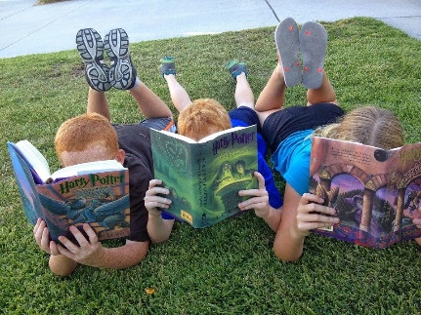 | SING a Song  Something you make up  Select from the Preschool list | Go for a WALK  Look at Clouds  Find a Rock
Do an EXPERIMENT,  Painted toast: Ingredients: 2 tablespoons milk, food coloring, clean paintbrush (small clean squeeze bootle), sandwich bread, toasterDirections: mix milk with a few drops of food coloring in a small container. Use paintbrush to paint design, rainbows, or faces on the bread.Then toast the bread, butter it and eat or make it into a sandwich | say your Favorite Prayer | RAINBOW WRITING-  Use different colored pencils/crayons and write each letter of their name in several colors, not ready for letters, use a flimsy paper plate and draw a circle along the ridges in various colors.
PLAY A GAME  Open an umbrella and in toss bean bags or balled up socks | MAKE PLAYDOUGH and CreateThe BEST homemade playdough recipe  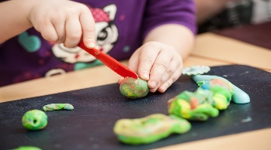 | RECYCLED CREATIONS-use various materials to color different items like a small box or make a collage with things like scraps of fabric, ribbons, snippets of yarn, pieces of foil, whatever you may have around the house

Scavenger Hunt

Directions:
Start with number 1 and follow in order.

FIND your NAME on a post it note | FIND 2 matching shoes or socks  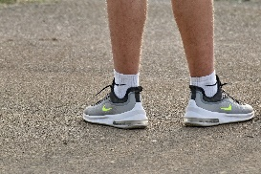 | FIND 3 blankets
Find 4 pillows | Say their Favorite Prayer | FIND some Chairs and a Sofa BUILD A FORT with your materials you found.  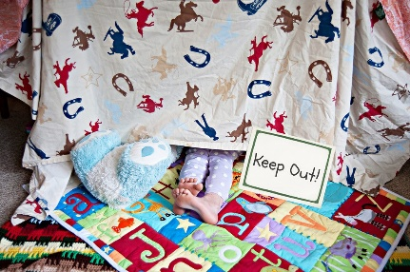
FIND PAPER and Crayons | DRAW A Treasure Map for a sibling or parent to find you. | RELOCATE and repeat steps or have a parent or sibling give you a map to find the treasure.  