Tic-Tac-Toe Choice Menu:
Anytime Activities

Directions:
Start with number 5 and then make two other choices to make your tic-tac-toe or fill the board

READ a Book  What will happen next  Retell story  I wonder...  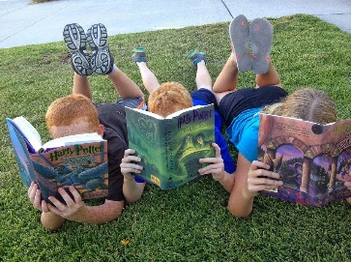 | MAKE a sensory item-take a deflated balloon, fill with corn starch and tie the top into a tight knot. Or wrap rubber bands around a can or tupperware container. It builds strong hand muscles. | PLAY Hopscotch, the kids love not stepping on cracks  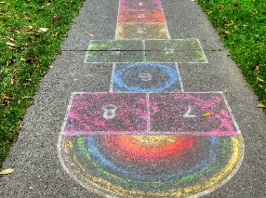
SORTING ITEMS:  Help with laundry by sorting socks, empty dishwasher silverware,  Cleaning toy room by sorting all blocks then balls then books (hey you’re sorting all items beginning with B). Time them and it becomes a game rather than a chore.  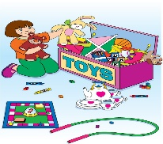 | Say your Favorite Prayer | Cut out coupons,  Use newspapers or magazines and find letters of their name and cut out, find pictures of eyes, nose, ears, mouth, arms, legs, body and make fun pictures.
PLAY FREEZE DANCE | COUNT to 100 and every 10 do a different action, 1-10 clap, 20-30 march, 30-40 jump, etc  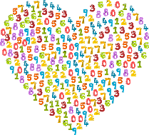 | GO on a BUG hunt-take 1 foot piece of rope make a circle and see what you can find-make a drawing of it  