ROLL DICE GAME
DO 1 TOOSHY KICK WITH EACH LEG
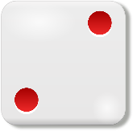 WALK BACKWARDS 2 STEP
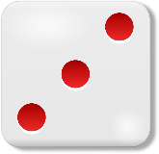GALLOP 3 STRIDES
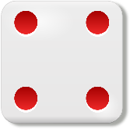FRANKENSTEIN WALK 4 PACES
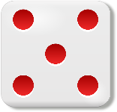RUN 5 LAPS
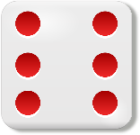MARCH 6 TIMES AROUND THE ROOM
FEEL FREE TO MIX IT UP AND ADD DICE TO BE ACTIVE AND DO MATH, CHANGE THE ACTIONS: SKIP, GIANT STEPS, BABY STEPS, TIP TOE, SIDEWAYS, SPIN AROUND, HOP ON 1 FOOT, JUMP ON 2 FEET
FOR OUR YOUNGER STUDENTS, USE A DECK OF CARDS INSTEAD OF DICE

